KEMENTRIAN PERHUBUNGAN

DIREKTORAT JENDERAL PERHUBUNGAN LAUT

DISTRIK NAVIGASI TIPE B TANJUNG PRIOK

LAPORAN KEHANDALAN PERANGKAT

INSTALASI : VTS MERAK

PERIODE : Juli 2024

|  |  |  |  |  |  |  |  |  |
| --- | --- | --- | --- | --- | --- | --- | --- | --- |
| **NO** | **SARANA PERALATAN VTS** | **ProsentaseKehandalanPeralatan**  **(a)** | **Jam Operasional Ideal / Bulan**  **(b)** | **Jumlah Jam Kelainan/ Bulan**  **(c)** | **PenyebabKelainan Jam pada Peralatan** | **Jam OperasionalEksisting / Bulan**  **(d = b – c)** | **ProsentaseEksistingKehandalanPeralatan**  **( x a %)** | **Keterangan** |
| 1 | Radar | 10% | 744 | 0 | Tersambarpetir | 744 | 10% |  |
|  | CCTV Camera Mediun Range | 2% | 744 | 0 |  | 744 | 2% |  |
| 2 | CCTV Camera Long Range | 3% | 744 | 744 | Power Suply tidak berfungsi | 0 | 0% |  |
| 3 | Automatic Identification System (AIS) | 30% | 744 | 0 |  | 744 | 30% |  |
| 4 | Radio Communication (Radio VHF) | 30% | 744 | 0 |  | 744 | 30% |  |
| 5 | Hydrological and Meteorlogical | 5% | 744 | 744 | Power Suply tida kberfungsi | 0 | 0% |  |
| 6 | VTS Data System | 10% | 744 | 0 |  | 744 | 10% |  |
| 7 | VTS Record and Reply System | 5% | 744 | 0 |  | 744 | 5% |  |
| 8 | Radio Direction Finder (RDF) | 2% | 744 | 744 | Radio Link Rusak | 0 | 0% |  |
| 9 | Peralatan dan Perangkat Pendukung VTS | 3% | 744 | 0 |  | 744 | 3% |  |
|  |  | 100% |  |  |  |  | **90%** |  |

Noted :

b = (24 Jam x Jumlah Hari dalam 1 Bulan)

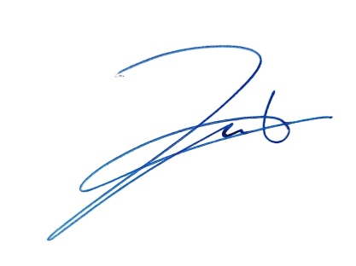Kepala VTS Merak

Mohammad Darsoni,S.Kom

Nip.19711009 199103 1 001